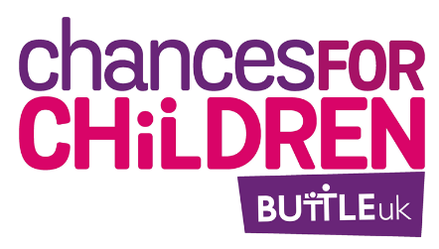
Buttle UK Youth Advisory Panel Application Form
We're really pleased that you're interested in joining Buttle UK's Youth Advisory Panel. Please complete the form below to tell us why you'd like to be involved.
There are three main questions to answer, plus some shorter questions asking for your information. Questions marked with a * are required.
You can write your answers (we suggest writing them out using this doc first, then pasting them into the online form) or you can make a video, record a voice note, or upload anything else creative that answers the questions. You can send us your creations using the "upload" button in the online form.
We want to have lots of different voices involved, so may make decisions based on where you live and your demographics, as well as your answers to the questions.
If you need help completing the form, contact Charlotte on coproduction@buttleuk.org.
Once you’ve used this document to write out your answers, please copy them into the online form here: https://go.makerble.com/to/YAPapplication

Your information
Full Name*:
What would you like us to call you? (e.g. William, Will, Bill, Mr Smith):
Which pronouns do you use? (tick all that apply)
- He/him
- She/her
- They/them
- Other
Phone*:
Email:
Have you or your family ever received a grant from Buttle UK?
- Yes
- No
Age*:
Date of birth:

Where in the UK are you from?
- England – East Midlands
- England – East of England
- England – London
- England – North East
- England – North West
- England – South East
- England – South West
- England – West Midlands
- England – Yorkshire and the Humber
- Northern Ireland
- Scotland
- Wales
Which city or town do you live in?*

Joining the Panel
Remember, you can write your answers to these questions (we suggest writing them out first and then pasting them into this form) or you can make a video, record a voice note, or upload anything else creative that answers the questions. You can send us your creations using the "upload" button after the questions in this section.
Please tell us why you'd like to join the Youth Advisory Panel (max two paragraphs or 1 min recording):

What would you bring to the Panel? For example, skills, attitude, experiences (max two paragraphs or 1 min recording)

What difference would you like to make by being on the Panel? (max two paragraphs or 1 min recording)

Can you commit to being on the panel for at least the next year?
- Yes
- No

About you
The following questions are optional but will help us make sure we have different voices and experiences involved in the project. If you don't want to answer any of these questions please leave them blank or tick "prefer not to say".
Gender:
- Male
- Female
- Transgender
- Gender neutral
- Non-binary
- Agender
- Pangender
- Other
- Prefer not to say
Ethnicity:
- White – English/Welsh/Scottish/Northern Irish/British
- White – Irish
- White – Gypsy or Irish Traveller
- White – Other
- Mixed – White and Black Caribbean
- Mixed – White and Black African
- Mixed – White and Asian
- Mixed – Other
- Asian – Indian / British Indian
- Asian – Pakistani / British Pakistani
- Asian – Bangladeshi / British Bangladeshi
- Asian – Chinese
- Asian – Other
- Black – African / African British
- Black – Caribbean / Caribbean British
- Black – Other
- Arab
- Any other ethnic group
- Prefer not to say
Would you describe yourself as having a disability or chronic health condition?
- Yes
- No
- Prefer not to say
Please let us know if there are any adjustments or support we can put in place that you would like to share with us at this stage. We will also ask about access/support requirements for specific activities:

Thanks for submitting your application! We'll be in touch soon.

