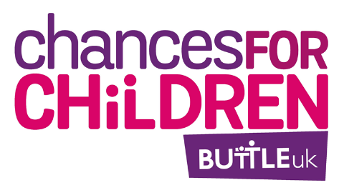
Invitation to tender
Buttle UK and early years impact May 2022
Research aims and objectives
We are looking for a researcher or a team of researchers to complete a piece of work by July 2023.
Primarily, we want to understand how Buttle UK’s grants are used when there are children aged 5 and under in the family, and what impact the grants have for early years children.
Secondarily, we are interested in understanding:
- What barriers exist for families and frontline workers in applying for Buttle UK grants where there are children aged five and under?
- What can Buttle UK consider in the future about supporting under-fives, in our processes and work? This in the context that we seek to support children and young people aged newborn to 20. 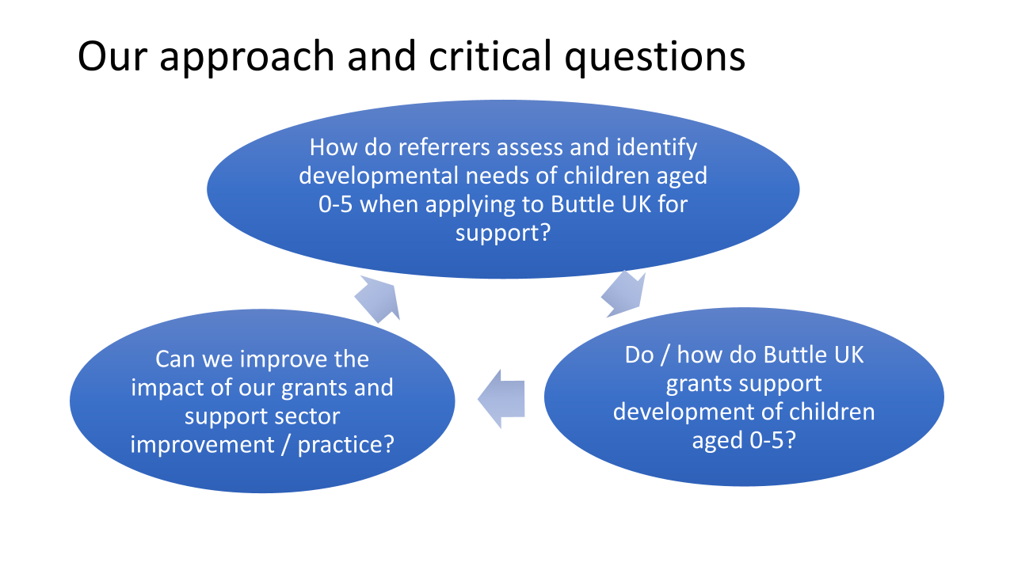
The research will be used:
- to develop how Buttle UK work and issue grants in the future
- to help frontline workers supporting families using Buttle UK grants
- the funder, Comic Relief, may use the research to help them understand early years support
Research experience and methods
We expect researchers to have a good understanding of early years development, the impact of poverty on children and the welfare and support infrastructure for vulnerable families in the UK.
Researchers must have experience and skills in qualitative and quantitative data collection and analysis, and with particular experience of conducting evaluations with children and vulnerable participants. We support and encourage applications from early career researchers across all sectors, as well as more experienced researchers, and support and encourage applications from underrepresented groups (including, but not limited to those in BAME and LGBTQ communities).
Buttle UK holds considerable data about our grant recipients and the awards – we will work with you to make relevant data available to you.
We are open to proposals from researchers about how to approach this research project. We recommend considering:
- Analysis of Buttle UK application data
- Interviews with Buttle UK grant making staff
- Interviews / observation / ethnographic research with families, potentially including children aged five and under (number to be decided)
- Interviews with a selection of frontline workers (number to be decided)
We have a Working Group of six frontline workers (some early year specialists and some who are not) who are supporting this project and can act as a focus group and first point of contact for the research team.
Principles
- Be guided by an ethical framework
- Demonstrate accountability, openness and honesty
- Be respectful and understanding of diversity and equity
- Proactive in problem-solving
- Be non-judgemental
Research outputs
We expect a report on the findings that includes recommendations for Buttle UK and the sector and are also open to discussing other outputs, including toolkits, animation or films that will help support the frontline referrers that we work with to improve early years outcomes using our grants.
Timescales
The research project should start in June / July 2023 and we would like the final report and research outputs by July 2023.

Budget
The budget is £20,000 in total, including VAT.
About Buttle UK
Buttle UK is an independent grant making foundation.

We were established in 1953 by the Reverend Frank Buttle, an East End Vicar who wished to support vulnerable children. Frank was determined to raise £1 million pounds to bring his foundation to fruition. When he died in 1953 he was only £80,0000 short of his £1,000,000 target. This is the foundation of our work.

Chances for Children Grants
Chances for Children grants are individually tailored grants of up to £2,000 for children and young people who have experienced a crisis that has recently had a significant and enduring impact on their social and emotional wellbeing and educational engagement. We focus on children and young people, from newborns to 20 year olds. You can read our eligibility criteria here: https://buttleuk.org/apply-for-a-grant/chances-for-children-grants/
We deliver grants across the UK. Applications are made to us by frontline professionals working directly with children, young people and families in need. The applications are assessed and administered by sector experienced Grant Development Officers who come from charities, the NHS, Social Care, local authorities, and youth service backgrounds.

In 2020-2021, we awarded £4.1m in Chances for Children grants to families. We usually award between £1.8 million to £3 million.

We evaluate and monitor the impact of our grants through surveys to young people, families and referrers, as well as deeper qualitative evaluations for areas and projects. You can read more here: https://buttleuk.org/our-research/

About this project
Buttle UK has been awarded funding from Comic Relief between 2020 and 2023 to explore how our grants are used with children aged five and under. We work with over 600 organisations referring to us across the UK for all ages of children. The referrers are all experienced, frontline professionals with differing knowledge and training across all age ranges. They range from health visitors to caseworkers in domestic violence refuges, to teachers and youth workers to housing officers. Only a proportion of them have an early years knowledge base and training.

- Referrers have fed back to us that they can struggle to identify trauma and impact in early years children, as opposed to developmental delay or tantrums, particularly when very young children are part of a larger family.
- Referrers are unsure what items to ask for as part of the grant support package for early years children, who may not be able to vocalise interests and needs.
- The Buttle UK team can struggle to fund grants for very young children and babies, particularly when budgets are tight, as we have to make difficult decisions to fund children who are demonstrably most deeply affected by trauma and crisis.
- We are also more unsure of the impact of our grants for this age range.

Whilst we award grants for early years children across the UK, we are focussing this project on two areas, the South East of England and North East of Scotland. This is to help us work closely with a range of organisations (some with early years experience and some without) and explore, with an early years focus, their practice and work and how our grantmaking fits with that.

Intellectual property rights
All intellectual property rights ("IP Rights") in all data and any other materials created by the Contractor in the course of delivering the Services under this Agreement will be owned by Buttle UK.
We will make the research freely available to the public within a reasonable period. We will acknowledge Comic Relief as the funder and must submit all publications to them for written approval in advance of publication. Comic Relief will have the right to use the results of such research or published work as it sees fit in whatever form such research or published work appears.
Management of the project
Whilst the above research will be primarily developed and conducted by the external evaluator, the Buttle UK Impact and Evaluation Manager and members of the grants team will be on hand to assist at all stages of the evaluation.
The project will be led at Buttle UK by the Head of Grants and Impact and Evaluation Manager. The Impact and Evaluation Manager will be the main project contact.
The tendering process
Please submit a tender response to recruitment@buttleuk.org by 5pm, Thursday 26 May 2022.
The response must include the following:
- an outline of your proposed research methods and methodology that demonstrate how you will deliver the work against the brief
- timescales for delivery
- budget setting out staffing and other costs (with number of days and daily fee per person clearly shown)
- CVs of researchers
- how you will address any ethical considerations
- how you will apply rigorous standards of safeguarding for children and vulnerable adults
- any requirements you have of Buttle UK as a commissioner
To discuss the tender and research project in advance of the deadline please contact Clare McGread, Head of Grants on 020 7828 7311
We will interview via Zoom on 8 or 9 June 2022.

